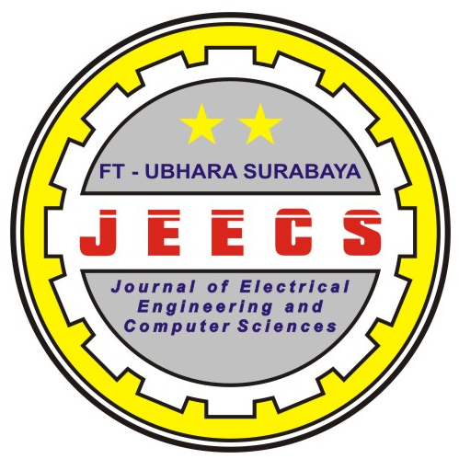

FAKULTAS TEKNIK
UNIVERSITAS BHAYANGKARA SURABAYA
Kampus: Jl. A. Yani 114 Surabaya Telp. 031-8285602, 8291055, Fax: 031- 8285601

Call For Paper JEECS Vol. 2 No. 2 (Dec 2017)

Dear Mr/Mrs Researcher
JEECS (Journal Of Electrical Engineering and Computer Sciences) is a scientific journal that presents and updated scientific articles in the field of Electrical engineering and Informatics Engineering (associated of Computer Sciences) as well as the application of research.
ISSN : 2528-0260
E-ISSN : 2579-5392
This journal is dedicated for the author or researcher who has focused in the field of technology and intending on publication and sharing knowledge the novel technology on Data Mining, Forecasting Systems, Informatics Algorithm and Methodology, Mobile Computing, advanced Computer Networks, Image Processing, Computer Vision, Robotics Technology, Etc. Publishing articles on this journal can be sent to Official address or you can read complete information / instructions to http://jeecs.ubhara.ac.id. The articles which would like to publish is selected go through a selection process by partner reviewer and or editors.
This Journal is published periodically twice a year on June and December.

Currently, JEECS is already indexed by Google Scholar and Citefactor. We look to get indexed immediately in DOAJ and other indexing agencies.
We invite you to submit paper for the edition Vol. 2 No. 2, Dec 2107, Important dates:
Submission paper : Nov 01 - Nov 08, 2017
Announcement of review : Nov 10, 2017
Camera ready : Nov 20, 2017
Online : Dec 1, 2017
Paper templates and writing guidelines can be accessed at the address: http://jeecs.ubhara.ac.id
Or for further information you can contact our online Support at +6285106100260

Best Rgds,
Editor in Chief JEECS

R. Dimas Adityo, S.T., M.T.

